To: Prof. Lydia Jane G.

SRS Document

ONLINE BOOKMARKING APPLICATION

**Problem Statement**

With the ever increasing number of websites and use of internet for numerous things, bookmarking important websites have significantly grown. But the present system has limited functionality, one cannot access their saved bookmarks from different computer. Our application will directly address this problem and provide mechanism to organize bookmarks, effectively manage them and the ability to access them from multiple devices.

**Background Information**

As we know that bookmarking webpages is a need of many. With increasing number of multipurpose computer devices, one need to access their bookmarks from multiple devices. The problem is, one cannot access the bookmarks saved on one device or one web browser on other. The target users here are all the people using internet who use bookmarks to save links and URL.

Their exist number of systems for saving bookmarks but none are similar to ours. The existing bookmarking systems are: the web browser integrated bookmarking systems which are available in all major web browsers such as Google Chrome, Mozilla Firefox, Internet Explorer, Opera, Safari, etc.

The limitations of existing systems is absence of universal accessibility of saved bookmarks and no proper organization of the same. One cannot access their saved bookmarks from other web browsers and/or other computer systems. Also the present systems have limited functionality in organization of saved bookmarks. Our application will provide universal accessibility of user’s saved bookmarks and easy classification and organization of the same.

**Stakeholders**

* Project Development and Design Team
* Customers/Users

**Requirements**

* **Functional Requirement**
  1. Register
  2. Log in
  3. Add New Bookmark
  4. Bookmark Current Page
  5. New Category
  6. Manage Category
  7. Manage Bookmarks
  8. User Account

**User Stories:**

|  |  |
| --- | --- |
| Use Case ID | 1 |
| Use Case Name | User Registration |
| Summary | * The user registration form has to be filled. * The form has various elements such as: * User Name * Email ID * Create Password * Confirm Password * Submit * All the fields will be “required”. * Password can be of any number of characters. |
| Conditions | The email ID has to be confirmed after the registration. |
| Success End Condition | Successfully Registered confirmation message is displayed to the user. |
| Failed End Condition | * Please fill in the required details / * Email ID is not valid / * User already registered. |
| Primary, Secondary Actors | User and System. |
| Trigger | This use case is initiated when a user in the application selects “Register”. |
| DESCRIPTION | Step | Action |
|  | 1. The end user click on the Register button. 2. The user is directed to the registration form, where he is asked to fill the form. 3. All the details are entered by the user. 4. Finally the user can submit the details by clicking the Register button. |
| EXTENSIONS | Step | Branching Action |
|  | 1. The systems checks the database for the email ID for already registered users. |
|  |  |

|  |  |
| --- | --- |
| Use Case ID | 2 |
| Use Case Name | User Login |
| Summary | * The user login fields has to be filled. * Various fields elements will be: * Email ID * Password * Login * Both the fields will be “required”. |
| Pre-Conditions | The user has to be already registered for the application. |
| Success End Condition | The user gets directed to his dashboard. |
| Failed End Condition | * Please fill in the required details / * Email ID or Password is not valid / * User is not registered. |
| Primary, Secondary Actors | User and System. |
| Trigger | This use case is initiated whenever the user attempts to “Login”. |
| DESCRIPTION | Step | Action |
|  | 1. The end user can directly fills the login details on the home page of the application. 2. The user fill in the login details. 3. Then the user can click login to get logged in. |
| EXTENSIONS | Step | Branching Action |
|  | 1. The systems checks the database for the email ID and password match. |
|  |  |

|  |  |
| --- | --- |
| Use Case ID | 3 |
| Use Case Name | Add New Bookmark |
| Summary | * The new bookmark details has to be filled. * Various fields will be: * Bookmark Name * Bookmark Description * URL * Select Category * New Category * Add * URL will be the required field. |
| Pre-Conditions | The user has to be logged in the application. |
| Success End Condition | Bookmark added successfully message is displayed to the user. |
| Failed End Condition | Please enter valid URL message is displayed. |
| Primary, Secondary Actors | User and System. |
| Trigger | This use case is initiated whenever the user selects “Add New Bookmark”. |
| DESCRIPTION | Step | Action |
|  | 1. The end user clicks on the “Add New Bookmark” tab. 2. The user is directed to fill the new bookmark details. 3. The fields are filled by the user. 4. Then the user can click Add to add the new bookmark. |
| EXTENSIONS | Step | Branching Action |
|  | 1. The system checks the database for the entered URL to avoid repetition. |
|  |  |

|  |  |
| --- | --- |
| Use Case ID | 4 |
| Use Case Name | Bookmark Current Page |
| Summary | * The current page’s URL is extracted. * The Add New Bookmark event is triggered. * The URL filed is auto filled. * Other fields to be filled will be: * Bookmark Name * Bookmark Description * Select Category * New Category * Add |
| Pre-Conditions | 1. The user has to be logged in the application. 2. The user has to be on some page on the internet. |
| Success End Condition | Bookmark added successfully message is displayed to the user. |
| Failed End Condition | Bookmark was not added! Message will be displayed. |
| Primary, Secondary Actors | User, System and third party webpage. |
| Trigger | This use case is initiated whenever the user selects “Bookmark Current Page”. |
| DESCRIPTION | Step | Action |
|  | 1. The end user clicks on the “Bookmark Current Page” tab. 2. The user is directed to fill the new bookmark details. 3. The URL is auto filled. 4. Other fields are filled by the user. 5. Then the user can click Add to add the new bookmark. |
| EXTENSIONS | Step | Branching Action |
|  | 1. The system retrieves the URL from the current web page. 2. The system checks the database for the entered URL to avoid repetition. |
|  |  |
|  |  |

|  |  |
| --- | --- |
| Use Case ID | 5 |
| Use Case Name | New Category |
| Summary | * To add a new bookmark category. * The new category field has to be filled. * Fields will be: * Category Name * Category Description * Create |
| Pre-Conditions | The user has to be logged in the application. |
| Success End Condition | New category will be created and the user will be directed back to parent step. |
| Failed End Condition | The user will be directed back to parent step. |
| Primary, Secondary Actors | User and System. |
| Trigger | This use case is initiated whenever the user selects “New Category”. |
| DESCRIPTION | Step | Action |
|  | 1. The end user clicks on the “New Category” tab. 2. The user is directed to fill the new category fields. 3. The user fills the details. 4. Then the user can click Create to add the new category. |
| EXTENSIONS | Step | Branching Action |
|  | Nil |
|  |  |

|  |  |
| --- | --- |
| Use Case ID | 6 |
| Use Case Name | Manage Category |
| Summary | * To manage existing categories. * All the existing categories are displayed. * Selecting any category will display all the bookmarks in that category along with category description. * Again selecting a bookmark will display the bookmark details. * Categories can be edited/deleted. |
| Pre-Conditions | The user has to be logged in the application. |
| Success End Condition | The user will be directed to home page of the application with all the changes saved. |
| Failed End Condition | The user will be directed to home page of the application without any changes. |
| Primary, Secondary Actors | User and System. |
| Trigger | This use case is initiated whenever the user selects “Manage Category”. |
| DESCRIPTION | Step | Action |
|  | 1. The end user clicks on the “Manage Category” tab. 2. All the categories will be displayed. 3. The user edits/deletes the desired categories and fields. |
| EXTENSIONS | Step | Branching Action |
|  | Nil |
|  |  |

|  |  |
| --- | --- |
| Use Case ID | 7 |
| Use Case Name | Manage Bookmarks |
| Summary | * To manage existing bookmarks. * All the existing bookmarks are displayed. * Selecting any bookmark will display all its details. * Bookmarks can be edited/deleted. * Uncategorized bookmarks can be categorized. |
| Pre-Conditions | The user has to be logged in the application. |
| Success End Condition | The user will be directed to home page of the application with all the changes saved. |
| Failed End Condition | The user will be directed to home page of the application without any changes. |
| Primary, Secondary Actors | User and System. |
| Trigger | This use case is initiated whenever the user selects “Manage Bookmarks”. |
| DESCRIPTION | Step | Action |
|  | 1. The end user clicks on the “Manage Bookmarks” tab. 2. All the bookmarks will be displayed. 3. The user edits/deletes the desired bookmarks and fields. 4. The category of a bookmarked can be changed. 5. Uncategorized bookmarks can be added with categories. |
| EXTENSIONS | Step | Branching Action |
|  | Nil |
|  | |

|  |  |
| --- | --- |
| Use Case ID | 8 |
| Use Case Name | User Account |
| Summary | * To update user information * To delete account. * All user information is displayed. * Following information can be updated. * User Name * Email ID * Password * The password is shown as hidden characters. |
| Pre-Conditions | 1. The user has to be already registered. 2. The user has to be logged in the application. |
| Success End Condition | Changes Saved Successfully messages confirmation will be displayed. |
| Failed End Condition | The user will be directed to home page of the application without any changes. |
| Primary, Secondary Actors | User and System. |
| Trigger | This use case is initiated whenever the user selects his Account. |
| DESCRIPTION | Step | Action |
|  | 1. The end user clicks on the “My Account” tab. 2. Complete user information will be displayed. 3. The user can view/update the desired fields. 4. Finally user clicks “Save” to save the changes. |
| EXTENSIONS | Step | Branching Action |
|  | 1. If the email is changed, the system will check it in database.0 |

**Use Case Diagram:**

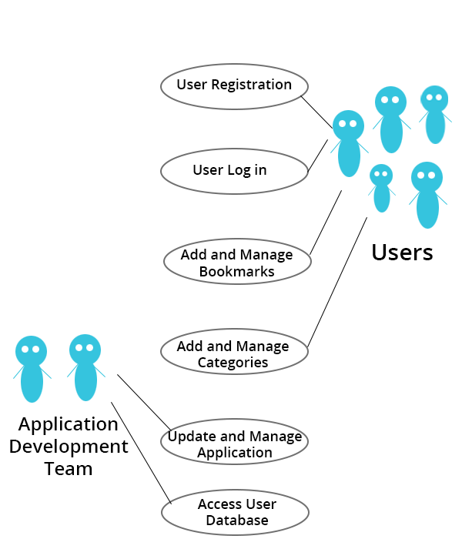

* **Non Functional Requirements**
* [Accessibility](http://en.wikipedia.org/wiki/Accessibility):   
  Anyone can use the application, there is no restriction to any person. The application can be accessed from the following internet enabled browsers:   
  Google Chrome, Mozilla Firefox and Internet Explorer (Version 8 and above). And minimum system specification required are: 500MB RAM, Core2Duo or higher processor.
* Security:   
  The application will be hosted on safe and secure cloud servers. All the registration information of the users will be safe and secure and will not be shared with any third party and the email will not be spammed.
* Failure Management:   
  In case of any disaster or unexpected failure the user’s data will not be compromised because it will be stored on reliable servers. And the application will be up and running within 1 hour in case of unexpected failure.
* Price:   
  The application is free to use. No charges of any kind to use the application will be collected.
* Response time:   
  The response time of the application will depend on the bandwidth of the internet at which the user is accessing the application. However the minimum time to load the application from our server side will be not more than 1.5 sec.
* Usability:   
  It will be extremely easy to use the application. It would take about 3 minutes to get to know all the features of application and how to use it. The new user registration will take 30 seconds.
* Scalability:   
  The application will be designed keeping in mind the population using the internet and so there will be real time monitoring of number of users registering for it and the extra window will be implemented. Also since the application will be hosted on cloud based servers, they can be unscaled anytime according to requirement.